Internship Report on
"Python Quiz Game"
Prepared by
Kashish Baranwal

Executive Summary
This report presents the work completed during the Industrial Internship organized by upskill Campus and The IoT Academy in collaboration with UniConverge Technologies Pvt. Ltd. (UCT).
The internship focused on learning Python programming through structured weekly modules, practical exercises, quizzes, and project development. Throughout the internship, I learned Python fundamentals including variables, data types, operators, conditional statements, loops, functions, NumPy, and Pandas. These concepts were applied to develop a Python Quiz Game using Visual Studio Code.
The Quiz Game is a console-based application that presents multiple-choice questions to the user, evaluates the responses, calculates the final score, percentage, and grade, and displays the result. The project was developed using basic Python programming concepts without any external libraries.
This internship provided valuable practical experience in programming, logical thinking, debugging, problem-solving, and software development. It enhanced my understanding of Python programming and strengthened my confidence in developing real-world applications.

TABLE OF CONTENTS
1 Preface 3
2 Introduction 4
2.1 About UniConverge Technologies Pvt Ltd 4
2.2 About upskill Campus 8
2.3 Objective 9
2.4 Reference 9
2.5 Glossary 10
3 Problem Statement 11
4 Existing and Proposed solution 12
5 Proposed Design/ Model 13
5.1 High Level Diagram (if applicable) 13
5.2 Low Level Diagram (if applicable) 13
5.3 Interfaces (if applicable) 13
6 Performance Test 14
6.1 Test Plan/ Test Cases 14
6.2 Test Procedure 14
6.3 Performance Outcome 14
7 My learnings 15
8 Future work scope 16

Preface
The Industrial Internship organized by upskill Campus in collaboration with UniConverge Technologies Pvt. Ltd. (UCT) and The IoT Academy provided me with an excellent opportunity to enhance my technical knowledge and gain practical exposure to Python programming. During the six-week internship, I learned the fundamentals of Python through structured learning modules, weekly assignments, quizzes, and hands-on project development.
Throughout the internship, I studied essential Python concepts such as variables, data types, operators, conditional statements (if, elif, else), loops, functions, NumPy, and Pandas. These concepts helped me build a strong foundation in Python programming and improve my logical thinking and problem-solving skills.
As part of the internship, I developed a Python Quiz Game using Visual Studio Code. The project is a console-based application that presents multiple-choice questions to the user, evaluates the responses, calculates the final score, percentage, and grade, and displays the overall result. This project allowed me to apply the programming concepts learned during the internship in a practical way.
The internship was well planned and divided into weekly learning modules. Each week focused on specific Python topics, followed by quizzes and practical tasks to reinforce learning. The final phase involved developing the project, testing it, preparing the documentation, and uploading the project to GitHub.
This internship significantly improved my confidence in programming and introduced me to software development practices, debugging, documentation, and version control. I sincerely thank UniConverge Technologies Pvt. Ltd. (UCT), upskill Campus, The IoT Academy, and all the trainers and mentors for providing valuable guidance and support throughout the internship.
Finally, I would like to encourage my juniors and fellow students to actively participate in such internship programs. They provide valuable practical experience, strengthen technical knowledge, and prepare students for future academic and professional opportunities.

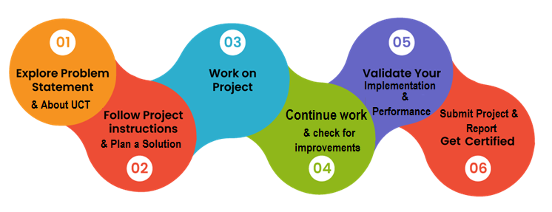

Introduction

About UniConverge Technologies Pvt Ltd
A company established in 2013 and working in Digital Transformation domain and providing Industrial solutions with prime focus on sustainability and RoI.
For developing its products and solutions it is leveraging various Cutting Edge Technologies e.g. Internet of Things (IoT), Cyber Security, Cloud computing (AWS, Azure), Machine Learning, Communication Technologies (4G/5G/LoRaWAN), Java Full Stack, Python, Front end etc.

- UCT IoT Platform()
UCT Insight is an IOT platform designed for quick deployment of IOT applications on the same time providing valuable “insight” for your process/business. It has been built in Java for backend and ReactJS for Front end. It has support for MySQL and various NoSql Databases.
- It enables device connectivity via industry standard IoT protocols - MQTT, CoAP, HTTP, Modbus TCP, OPC UA
- It supports both cloud and on-premises deployments.
It has features to
• Build Your own dashboard
• Analytics and Reporting
• Alert and Notification
• Integration with third party application(Power BI, SAP, ERP)
• Rule Engine

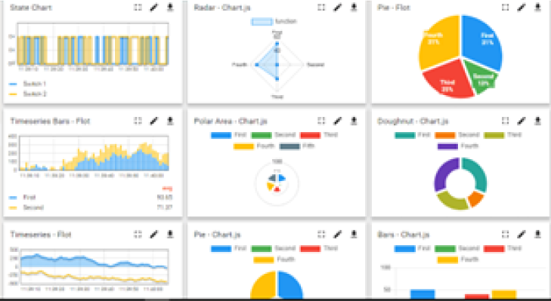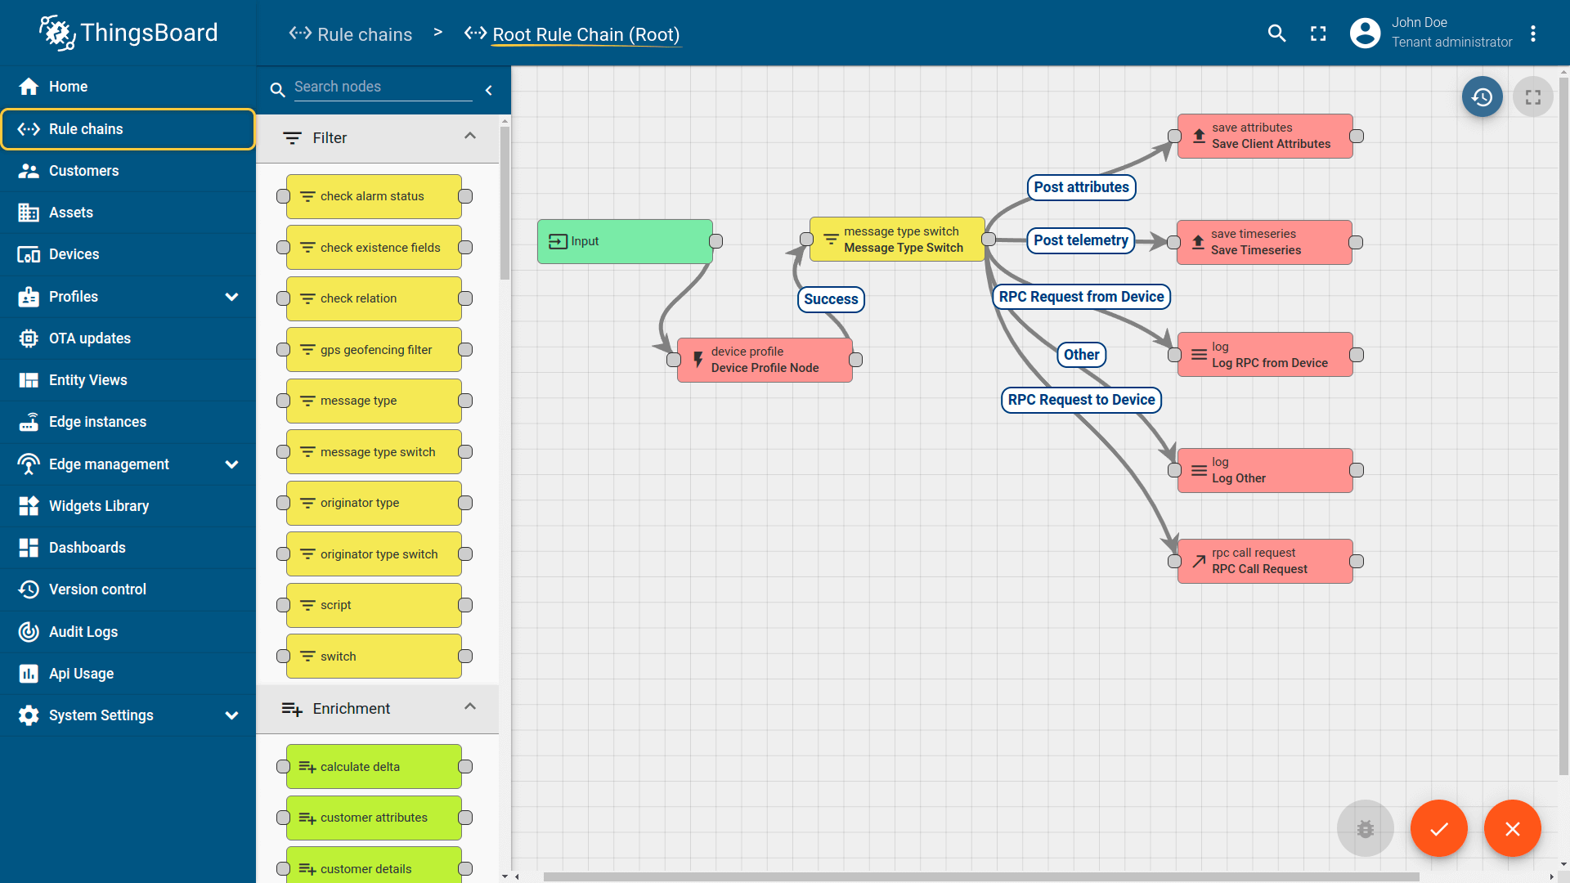

- Smart Factory Platform ()
Factory watch is a platform for smart factory needs.
It provides Users/ Factory
- with a scalable solution for their Production and asset monitoring
- OEE and predictive maintenance solution scaling up to digital twin for your assets.
- to unleased the true potential of the data that their machines are generating and helps to identify the KPIs and also improve them.
- A modular architecture that allows users to choose the service that they what to start and then can scale to more complex solutions as per their demands.
Its unique SaaS model helps users to save time, cost and money.
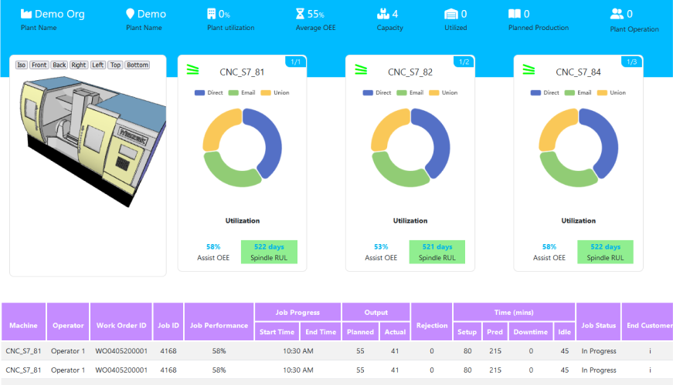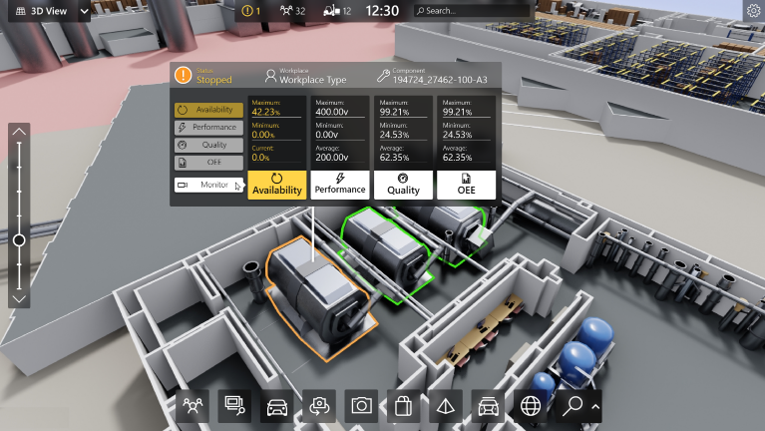

- based Solution
UCT is one of the early adopters of LoRAWAN teschnology and providing solution in Agritech, Smart cities, Industrial Monitoring, Smart Street Light, Smart Water/ Gas/ Electricity metering solutions etc.
- Predictive Maintenance
UCT isproviding Industrial Machine health monitoring and Predictive maintenance solution leveraging Embedded system, Industrial IoT and Machine Learning Technologies by finding Remaining useful life time of various Machines used in production process.
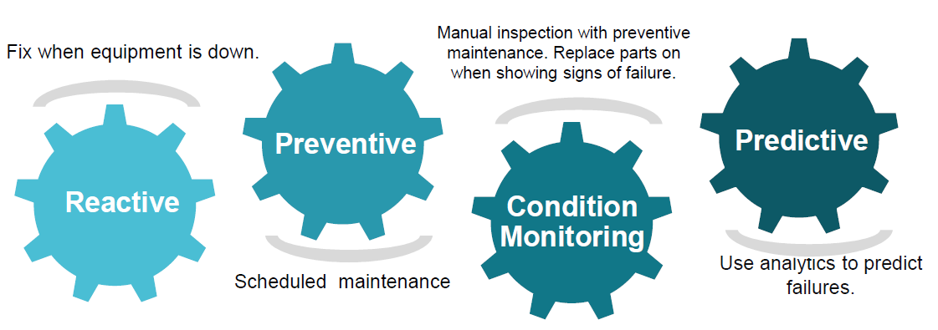

About upskill Campus (USC)
upskill Campus along with The IoT Academy and in association with Uniconverge technologies has facilitated the smooth execution of the complete internship process.
USC is a career development platform that delivers personalized executive coaching in a more affordable, scalable and measurable way.




Seeing need of upskilling in self paced manner along-with additional support services e.g. Internship, projects, interaction with Industry experts, Career growth Services
https://www.upskillcampus.com/
upSkill Campus aiming to upskill 1 million learners in next 5 year

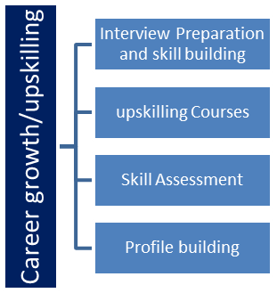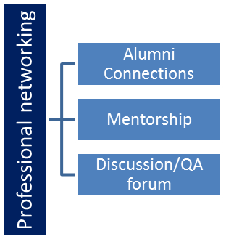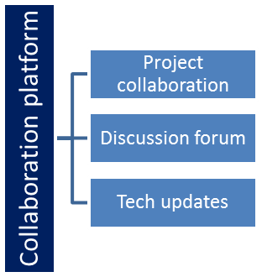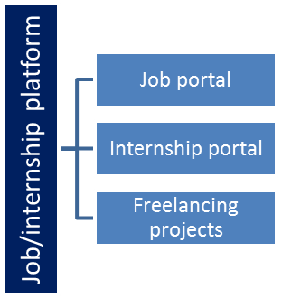

The IoT Academy
The IoT academy is EdTech Division of UCT that is running long executive certification programs in collaboration with EICT Academy, IITK, IITR and IITG in multiple domains.

Objectives of this Internship program
The objective for this internship program was to
☛ get practical experience of working in the industry.
☛ to solve real world problems.
☛ to have improved job prospects.
☛to have Improved understanding of our field and its applications.
☛to have Personal growth like better communication and problem solving.

Problem Statement
The objective of this project is to develop a Python Quiz Game using basic Python programming concepts. The application is designed to present multiple-choice questions to the user, accept the user's answers, evaluate their responses, calculate the total score, percentage, and grade, and display the final result.
The project aims to provide a simple and interactive learning platform where users can test their Python knowledge while improving their understanding of programming concepts. The application uses fundamental Python concepts such as variables, data types, lists, dictionaries, loops, functions, and conditional statements (if, elif, and else).
The Quiz Game was developed as a console-based application using Visual Studio Code without using any external libraries. The project demonstrates how basic Python programming concepts can be combined to build a practical and user-friendly application.

4 Existing and Proposed solution

Existing Solution
Many quiz applications are available on websites and mobile platforms. These applications allow users to answer multiple-choice questions and receive scores. However, most existing solutions require an internet connection, user registration, or advanced software frameworks. They are often designed for large-scale use and can be difficult for beginners to understand or develop. Some applications also contain advertisements or paid features, which reduce the learning experience.

Limitations of Existing Solutions
- Requires an internet connection.
- Some applications require user login or registration.
- Many are developed using advanced technologies that are difficult for beginners.
- Limited understanding of the internal working of the application.
- Paid features may restrict access to all quiz content.

Proposed Solution
The proposed solution is a Python Quiz Game developed using basic Python programming concepts. It is a console-based application created in Visual Studio Code without using any external libraries. The application displays multiple-choice questions, accepts the user's answers, evaluates each response, calculates the total score, percentage, and grade, and displays the final result.
The project is simple, lightweight, and easy to understand. It demonstrates the practical implementation of Python concepts such as variables, lists, dictionaries, loops, functions, and conditional statements. The application can run on any computer with Python installed and does not require an internet connection.

Value Addition
This project provides several benefits:
- Strengthens understanding of Python programming fundamentals.
- Improves logical thinking and problem-solving skills.
- Provides a simple and interactive way to practice Python concepts.
- Can be easily modified by adding more questions or different quiz categories.
Can be upgraded in the future by adding a graphical user interface (GUI), timer-based questions, • database connectivity, user login, score history, and random question generation.
- • Serves as a beginner-friendly project for learning software development and preparing for more advanced Python applications.

Code submission (Github link)
https://github.com/Kashish-18-wq/upskillcampus/blob/main/QuizApplication.py

Report submission (Github link) :
https://github.com/Kashish-18-wq/upskillcampus/blob/main/PythonQuizGame_Kashish_USC_UCT.docx

Proposed Design/ Model

The proposed solution is a console-based Python Quiz Game developed using Visual Studio Code and basic Python programming concepts. The application is designed to provide an interactive and user-friendly environment where users can test their Python knowledge through multiple-choice questions.
The workflow of the application is as follows:
- The program starts and displays a welcome message.
- The user is asked to enter their name.
- The application loads a predefined set of multiple-choice questions.
- Each question is displayed one by one along with four answer options.
- The user enters their selected option (A, B, C, or D).
- The program compares the user's answer with the correct answer.
- If the answer is correct, the score is increased by one; otherwise, the correct answer is displayed.
- This process continues until all the questions have been attempted.
- After completing the quiz, the application calculates the total score, percentage, and grade.
- The final result is displayed, showing the player's name, correct answers, wrong answers, percentage, and overall grade.
- The user is then given the option to play the quiz again or exit the application.
The application follows a simple modular design that makes it easy to understand, maintain, and extend with additional features such as timers, random question generation, score history, or a graphical user interface in the future.

High Level Diagram (if applicable)
+----------------------+
| Start Quiz |
+----------------------+
|
v
+----------------------+
| Enter Player Name |
+----------------------+
|
v
+----------------------+
| Display Questions |
+----------------------+
|
v
+----------------------+
| User Selects Answer |
+----------------------+
|
v
+----------------------+
| Check Answer |
+----------------------+
|
v
+----------------------+
| Update Score |
+----------------------+
|
v
+----------------------+
| Show Final Result |
+----------------------+
|
v
+----------------------+
| End |
+----------------------+

Figure 1: HIGH LEVEL DIAGRAM OF THE SYSTEM

Low Level Diagram (if applicable)

Start
|
v
Initialize Questions List
|
v
Initialize Score = 0
|
v
Display Question
|
v
Take User Input
|
v
Is Answer Correct?
| |
Yes No
| |
Score +1 Score Same
| |
+------+
|
v
Next Question?
|
Yes | No
|
v
Calculate Percentage
|
v
Assign Grade
|
v
Display Result
|
v
End

Interfaces (if applicable)
The application uses a simple Command Line Interface (CLI) developed in Python using Visual Studio Code.
The interface consists of:
- Welcome screen
- Player name input
- Display of quiz questions
- Multiple-choice options
- User answer input
- Correct/Wrong response
- Final score display
- Percentage display
- Grade display
- Play Again option
The interface is simple, user-friendly, and easy to understand for beginners.

Performance Test

The Python Quiz Game was tested to verify that it performs correctly under different user inputs and conditions. The application was evaluated based on functionality, accuracy, response time, and reliability. Since the project is a lightweight console-based application developed using basic Python, it requires very little memory and executes efficiently on any system with Python installed.
The main constraints considered during the development were ensuring accurate score calculation, correct answer validation, smooth user interaction, and error-free execution. The application was designed to process user input immediately and display the results without noticeable delay.
The project was tested using both correct and incorrect answers to verify that the score, percentage, and grade calculations were accurate. Multiple executions confirmed that the application performed consistently and produced the expected output.
The performance testing showed that the application is stable, user-friendly, and suitable for educational purposes. Future improvements such as a graphical interface, database integration, and timer-based questions can be added without affecting the overall design.

Test Plan/ Test Cases
Q.No | Your Ans | Corrrect Ans | Result
1 | B | B | True
2 | C | C | True
3 | B | B | True
4 | B | B | True
5 | B | B | True

Final Project Result
- Total Questions: 5
- Correct Answers: 5
- Wrong Answers: 0
- Final Score: 5/5
- Accuracy: 100%
- Result: PASS (Excellent Performance)

question_no | question | your_answer | correct_answer | is_correct
1 | Which keyword is used to define a function in Python? | B | B | True
2 | Which data type is immutable in Python? | C | C | True
3 | What does the len() function do? | B | B | True
4 | Which library is primarily used for numerical arrays in Python? | B | B | True
5 | Which statement is used for decision making in Python? | B | B | True

Test Procedure
The following steps were followed to test the application:
- Open the project in Visual Studio Code.
- Run the QuizGame.py program using Python.
- Enter the player's name when prompted.
- Attempt the quiz by selecting different answer options.
- Verify that each answer is evaluated correctly.
- Check whether the score updates after every correct answer.
- Verify the percentage and grade calculations after completing the quiz.
- Test the Play Again option to ensure the quiz restarts correctly.
- Repeat the testing with different answers to confirm consistent performance.
All the test cases were executed successfully, and the application produced the expected results without any runtime errors.

Performance Outcome
The performance testing confirmed that the Python Quiz Game functions correctly and efficiently. The application responded instantly to user input and accurately evaluated each answer. The score, percentage, and grade calculations were correct for all tested scenarios.
The project consumed minimal system resources and executed smoothly on a standard computer using Python and Visual Studio Code. No crashes or runtime errors were observed during testing.
Overall, the project met all the functional requirements and demonstrated the successful implementation of Python programming concepts in a practical application.

My learnings

The six-week Industrial Internship organized by upskill Campus, The IoT Academy, and UniConverge Technologies Pvt. Ltd. (UCT) was a valuable learning experience that helped me strengthen both my technical and problem-solving skills.
During the internship, I learned the fundamentals of Python programming, including variables, data types, operators, conditional statements (if, elif, else), loops, functions, lists, dictionaries, and basic file handling. I also gained knowledge of important data science libraries such as NumPy and Pandas, which are widely used for numerical computation and data analysis.
The weekly quizzes and practical assignments helped me revise the concepts regularly and improve my logical thinking. As part of the internship, I developed a Python Quiz Game using Visual Studio Code, where I applied the concepts learned throughout the training. This project improved my understanding of programming logic, debugging, user input handling, score calculation, and project development.
Apart from technical knowledge, I also learned the importance of project planning, documentation, testing, and version control using GitHub. These skills gave me practical exposure to the software development process and helped me understand how real-world projects are managed.
This internship has increased my confidence in programming and motivated me to continue learning advanced Python concepts, data science, and software development. The knowledge and experience gained during this internship will help me perform better in future academic projects, internships, coding competitions, and placement opportunities. It has also strengthened my foundation for building a successful career in software engineering and artificial intelligence.

Future work scope

The current Python Quiz Game is a simple console-based application developed using basic Python. In the future, the project can be enhanced with several advanced features to improve functionality and user experience.
Possible future enhancements include:
- Develop a Graphical User Interface (GUI) using Tkinter.
- Add a timer for each quiz question.
- Store quiz questions in a database.
- Randomize questions each time the quiz starts.
- Introduce multiple quiz categories such as Python, General Knowledge, Sports, and Science.
- Implement user login and registration.
- Store previous scores and maintain a score history.
- Display performance statistics using charts and graphs.
- Increase the number of quiz questions and difficulty levels.
These enhancements will make the application more interactive, scalable, and suitable for real-world educational use.

